Looking at a dataset of crowdfunding campaigns it appears that the best time to launch a crowdfunding campaign is within June and/or July, the most backed type of campaign to seek funds for are Theater/Plays, and that the least likely launch windows for a successful campaign are during the months of August and December, with more cancellations as well as failures during these launch times.

As shown in the above table, the fewest successful campaign launches by percentage were in the months of August and December. Higher cancellations contribute to additional negative outcome likelihood during these months.

The category that receives the most backers by an incredible margin is Theater/Plays. When seeking crowdfunding, although the outcome is similar across many categories, the potential pool of backers appears to be significantly larger than other crowdfunding types.

|  |  |  |
| --- | --- | --- |
| **Successful** | **Failed** |  |
| 851 | 586 | **Mean** |
| 201 | 115 | **Median** |
| 85 | 1 | **Mode** |
| 16 | 0 | **Min** |
| 7295 | 6080 | **Max** |
| 1603374 | 921575 | **Variance** |
| 1266 | 960 | **St.Dev** |

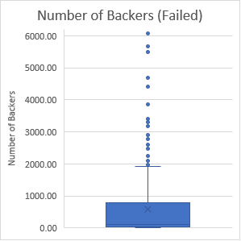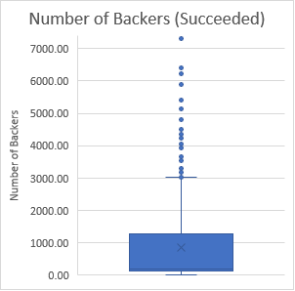

With so many data points outside of the first two standard deviations I would suggest the Mean for analysis, as these outliers are probably quite valid points and should be included.